**New rate matrix**

**Generic Resources**

If the Generic Resources have “Dettaglio Fornitore”: centrico, selir, Centrico India, nivola, the rate to be applied is “C-GI Centrico Generic Rate Italia” (only for “Italia”) (386/7,5) / “C-G Centrico Generic Rate” (for all the other resources) (386/8). The cost account code is LC01- Investimenti Risorse Centrico.

If the Generic Resources have “Dettaglio Fornitore” different from: centrico, selir, Centrico India, nivola or “Dettaglio Fornitore” field is blank, the rate to be applied is “NC-GI No Centrico Generic Rate Italia” (only for “Italia”) (286/7,5) / “NC-G No Centrico Generic Rate” (for all the other resources) (286/8). The cost account code is LC02 – Costo del Personale.

The generic resources will remain those currently existing in the system.

The request is to create a new rate matrix based on the “Cliente Pagante”.

In the “pt_tbl_tariffario_senza_prog” file you can find the Column G with the company code (COS level 1) relating to the “Cliente Pagante”.

If in column H there is “N”:

Named Resources with centrico, selir, Centrico India, nivola departments: the rate in column F is to be applied. The cost account code is LC01- Investimenti Risorse Centrico.

The rate is daily, therefore it must be divided by:

8h per day for:

* External Resources and Location= Italia, India, Romania
* Internal Resources and Location = India, Romania

7,5h per day for:

* Internal Resources and Location = Italia

Named Resources with departments different from centrico, selir, Centrico India, nivola:

For Internal Resources the rate to be applied is “NC-I No centrico internal rate Italia” (only for “italia”) (286/7,5)/ “NC No centrico Rate” for all the other resources (286/8). The cost account code is LC02 – Costo del Personale.

For External Resources the rate to be applied is “NC No centrico rate” (286/8). The cost account code is LC02 – Costo del Personale.

If in column H there is “Y” it is necessary to check the list of the resources in “pt_tbl_tariffe_delivery” file: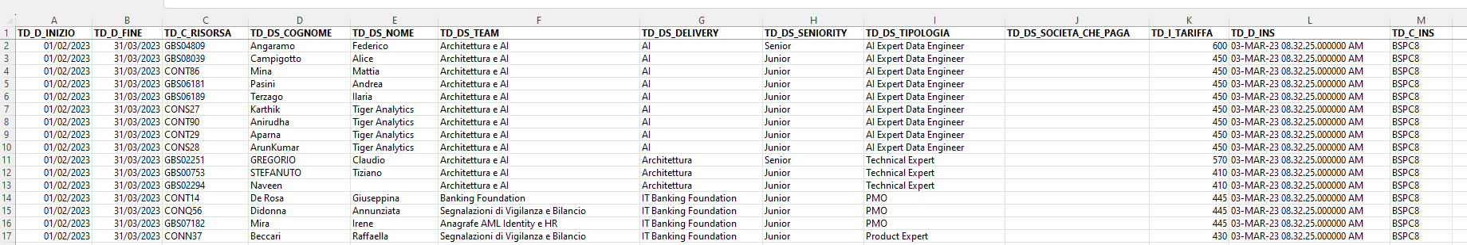

If the resource code is present in column C of the file the daily rate present in column K and item LC01 must be applied (for hourly rates check the rules above).

If the resource code is not present in column C then it will be necessary to apply the daily rate present in column F of the “pt_tbl_tariffario_senza_prog” file:

Named Resources with departments: centrico, selir, Centrico India, nivola, rate in column F and the cost account code is LC01- Investimenti Risorse Centrico.

Named Resources with departments different from centrico, selir, Centrico India, nivola:

For Internal Resources the rate to be applied is “NC-I No centrico internal rate Italia” (only for “italia”) (286/7,5)/ “NC No centrico Rate” for all the other resources (286/8). The cost account code is LC02 – Costo del Personale.

For External Resources the rate to be applied is “NC No centrico rate” (286/8). The cost account code is LC02 – Costo del Personale.

If there are two values in the widget “Cliente Pagante” it is necessary to take the company of the first value.

The files will be sent by the customer through the import procedure 11 and 12.

**Existing assignments:**

The existing assignments must not undergo changes in the past but, from date X onwards, the hours must be valued with the new rate matrix.

**Rate Duration:**

In the “pt_tbl_tariffario_senza_prog” and in the “pt_tbl_tariffe_delivery” file it is also necessary to consider the duration of the rates.

“pt_tbl_tariffario_senza_prog” file:

Column D of the file indicates the start date of the rate and column E of the file indicates the end date.

The rate indicated in column F is valid only within the dates indicated



“pt_tbl_tariffe_delivery” file:

Column A of the file indicates the start date of the rate and column B of the file indicates the end date.

The rate indicated in column K is valid only within the dates indicated

